Consulting Homework 8

Tim Vigers

09 May 2019

This analysis started out with 293 responses in total. Of these, 5 were excluded because the participant did not agree to the terms and conditions. Of the remaining 288 participants, 266 answered that they had been hiking with a pack weighing 10 lbs or more in past 3 years. An additional participant was excluded for indicating that they are over 89 years of age. Out of the remaining 265 participants, 240 responded to the question about back pain in the past 3 years, so this was group was used as the final analysis cohort.

Participants who did not answer “Yes” to the above questions were also excluded.

### Table 2: Descriptive statistics, participants with pain while day hiking

|  |  |  |
| --- | --- | --- |
|  | Overall | Data Missing (n) |
| n | 97 |  |
| Pain Location n (%) |  | 0.0 |
| Neck | 20 (20.6) |  |
| Mid back/shoulder blade | 37 (38.1) |  |
| Low back | 38 (39.2) |  |
| I do not experience back pain while day hiking with a pack | 2 ( 2.1) |  |
| Pain Frequency n (%) |  | 1.0 |
| Never | 3 ( 3.1) |  |
| Rarely | 42 (43.8) |  |
| Frequently | 46 (47.9) |  |
| Always | 5 ( 5.2) |  |

Ninety seven out of the 240 participants in the analysis set experience pain while day hiking. Of these, the reported pain location was fairly evenly split betweenmid back (38.1%) and low back (39.2%). However, 2 participants then said they never experienced pain when choosing from the picture, and 5 said they never experienced pain in response to the frequency question, so there are some discrepancies in this self-reported data.

### Table 3: Fitting statistics, stratified by pain while day hiking

|  |  |  |  |
| --- | --- | --- | --- |
|  | No Pain | Pain | Data Missing (%) |
| n | 143 | 97 |  |
| Professional Fit = No n (%) | 109 (82.6) | 78 (85.7) | 7.1 |
| Physical Conditioning = No n (%) | 90 (70.9) | 60 (67.4) | 10.0 |
| Hip Belt = Yes n (%) | 124 (86.7) | 82 (84.5) | 0.0 |
| Load Lifters = Yes n (%) | 91 (63.6) | 68 (70.1) | 0.0 |
| Sternal Strap = Yes n (%) | 110 (76.9) | 71 (73.2) | 0.0 |
| Adjustable Torso Length = Yes n (%) | 50 (35.0) | 33 (34.0) | 0.0 |
| External Frame = Yes n (%) | 4 ( 2.8) | 2 ( 2.1) | 0.0 |
| Internal Frame = Yes n (%) | 85 (59.4) | 56 (57.7) | 0.0 |

Although significance testing was not performed, the proportions for all variables appear to be similar between those with and without back pain while day hiking.

### Figure 1: Back pain severity by professional fit status

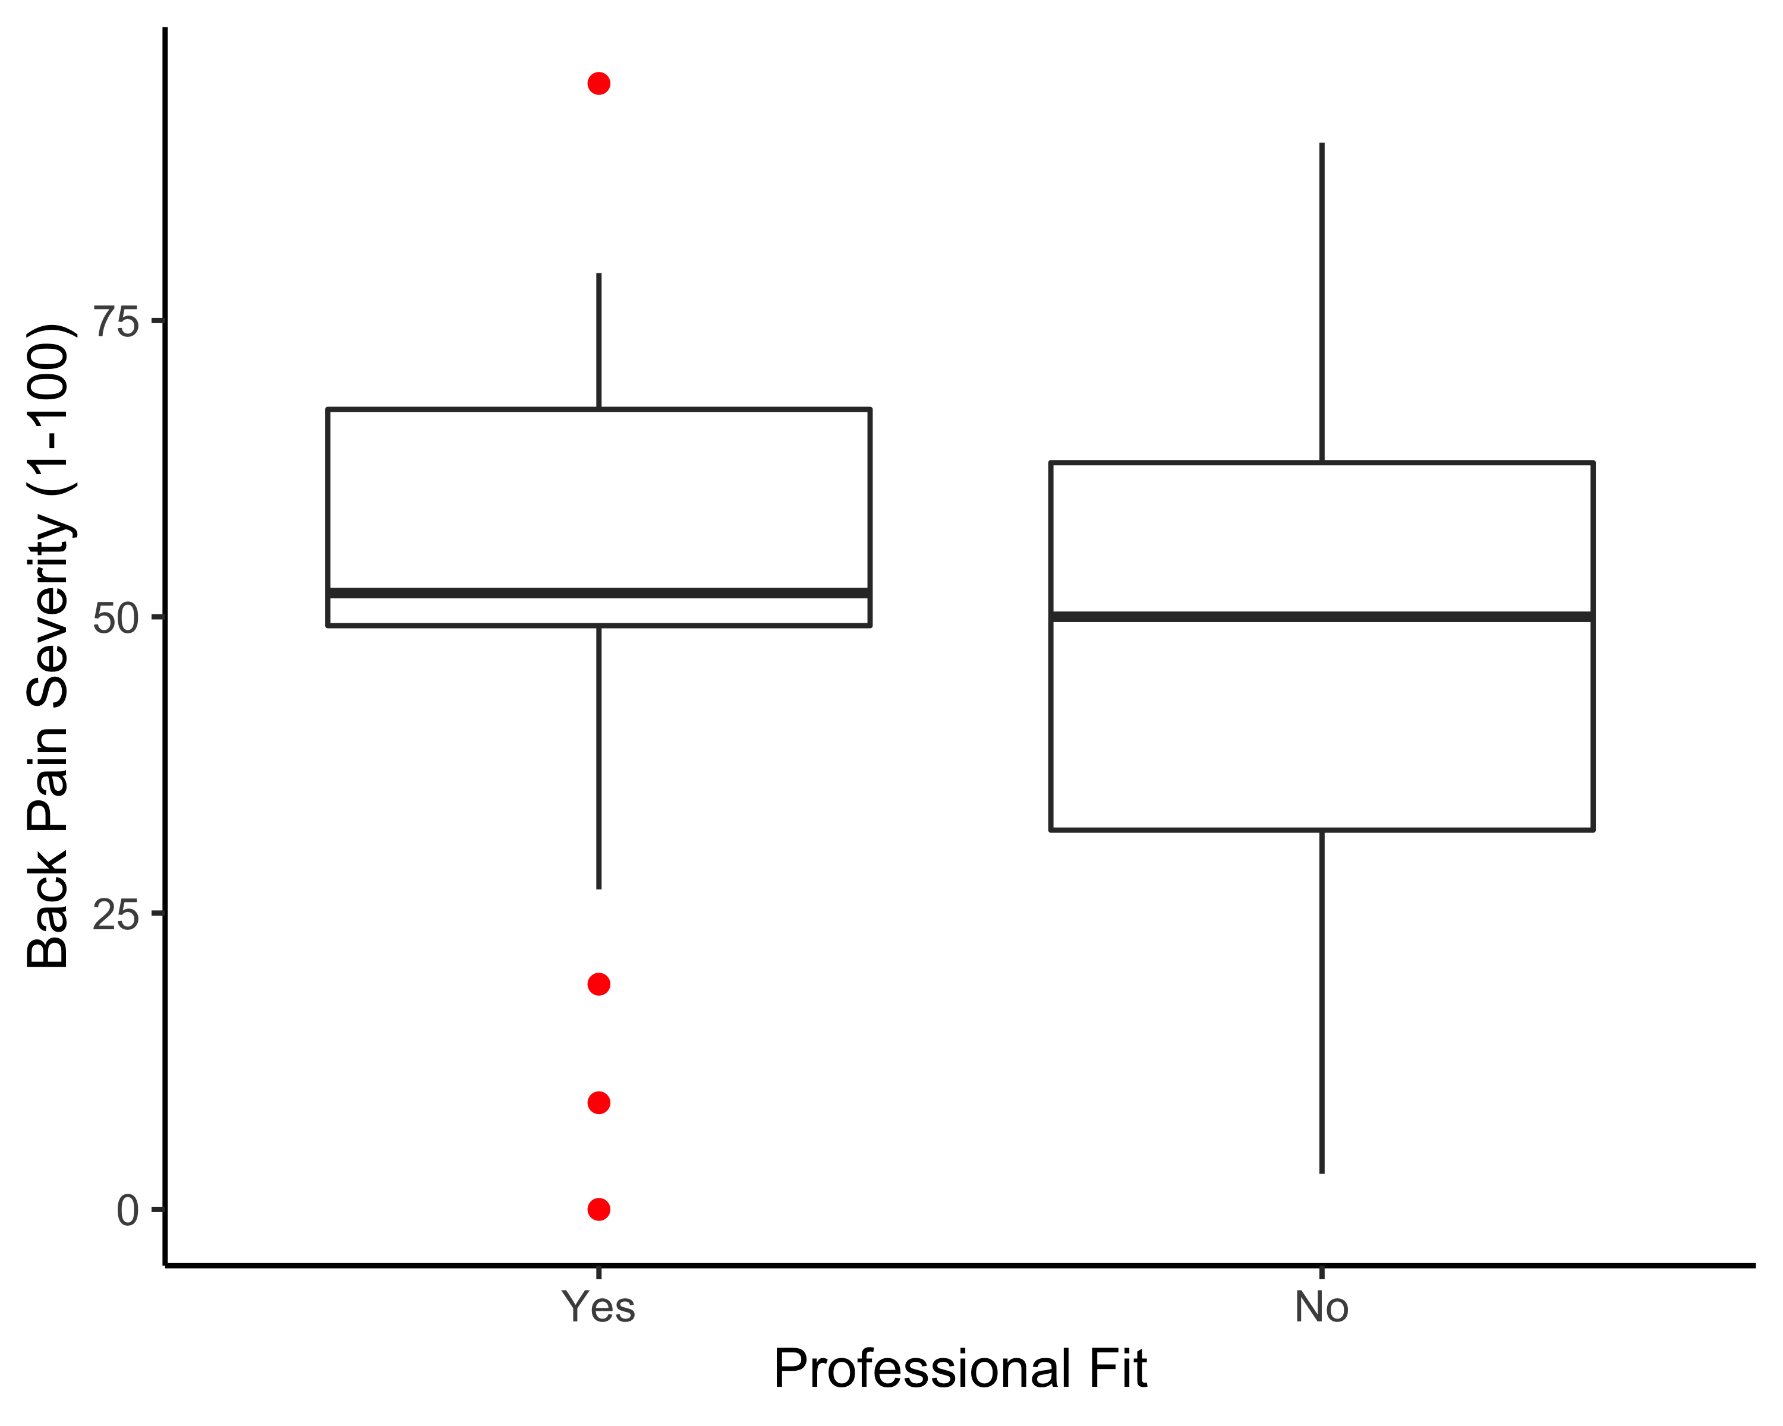

Interestingly, it appears from Figure 1 that the median and maximum back pain severity was slightly worse in those who had been professionally fit compared to those who were not (although again significance testing was not performed).